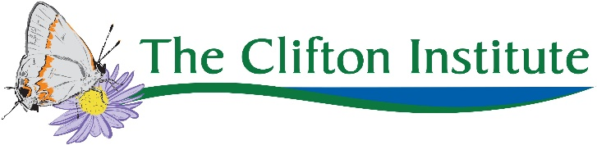
Nature Yoga: Photo Release & Waiver of Liability
Full name: _________________________________________________________________________
Emergency contact: ______________________________ Phone #: ____________________________
Do you have any health or medical issues we should be aware of? If yes, please communicate such information to the teacher.  Yes  No
Do we have permission to take still photos/images/video of you to be used, without compensation, as determined by the Clifton Institute?  Yes  No

I hereby agree to the following:
- That yoga requires physical exertion, which may be strenuous and may cause physical injury, and I am fully aware of the risks and hazards involved.
- That it is my responsibility to consult with a physician prior to and regarding my participation in any physical fitness program, including yoga. I represent and warrant that I have no medical condition that would prevent my participation in physical fitness activities.
- To assume full responsibility for any risks, injuries or damages, known and unknown, which I might incur as a result of participating in the class.
- That activities outdoors can be hazardous and may involve risks, including but not limited to risks arising from unaccustomed physical activity, risks related to the water, such as drowning, risks arising from exposure to biting and/or stinging insects and plant irritants, and risks related to the weather and other forces of nature.
- To indemnify and hold harmless the Clifton Institute and its respective employees, agents and affiliates for any injury or damages to any other person caused by negligence or intentional acts or inactions during this activity.
I understand my or my minor child’s participation in activities at the Clifton Institute, Inc. may expose me/my minor child to these and other risks and dangers, and could result in injury, illness, damage to property or even death. I hereby forever release the Clifton Institute, Inc., and its respective employees, agents and affiliates from all liability and responsibility for any claims, losses or demands relating to injury, death or damages to myself, my minor child or his/her property, including claims, losses or demands caused or alleged to be caused in whole or in part by the negligence of the Clifton Institute, Inc., or any of the above entities, except to the extent that such injury, death or damages is caused solely by any of their gross negligence or willful misconduct. I knowingly, voluntarily, and expressly waive any claim I may have against the instructor or The Clifton Institute for injuries or damages that I may sustain as a result of participating in yoga classes.
I have read the above release and waiver of liability and fully understand its contents. I voluntarily agree to the terms and conditions stated above.

Signed: _____________________________________________ Date: __________________

