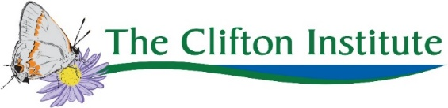
Summer Camp 2021 Scholarship Application
Scholarships cover all of camp tuition except a $50 deposit.
DO NOT REGISTER. No partial refunds will be given if you pay the full tuition before requesting a scholarship. We will temporarily reserve spots for pending scholarship applications.
Funding is limited and scholarships are not guaranteed to all applicants. Scholarships are awarded on a first come, first served basis and are available until all funds are awarded or until camp fills up.
Please fill out one form per family, not per child.
Camp name:
- Piedmont Polliwogs
- Young Explorers Week 1 (July 19-23)
- Young Explorers Week 2 (July 26-30)
- Young Scientists Research Experience
Application Date:
Name of parent/caregiver:
Name of child(ren):
Address:
Phone number:
Email:
Is your total annual household income less than $50,000?
- Yes
- No
If no, are there extenuating circumstances that you believe qualify your family for financial assistance?
- Yes
- No
Please fill out this form and send it to Alison at azak@cliftoninstitute.org. Thanks!

